**PROJECT REPORT OF HACKATHON**

**ON**

**MBRAKSHAK**

**INTRODUCTION**

**1.1 PURPOSE:**

The purpose of this document is to sketch out complete Software requirements to generate a **MBRAKSHAK** app which in hindi means “mei bhi rakshak” for protecting women from every kind of threat like eve teasing, rapes and molestation etc. Violence and discrimination can blight women’s lives and hold them back from playing a full part in the workplace, society and the economy. We’re taking action to improve women’s rights and safety in the communities in which we operate. This app is designed to respect and protect women rights which include the right to safety for women and girls But the thing to be noticed is that even on having in spite of having so many app that are designed for women safety stills the women lacks for their safety in their daily live .Every day more than 1000 cases are reported for woman molestation ,rapes and eve teasing etc. So basically through this app we are trying to make an effort for women safety which will guard the women with the help of volunteers those who think women safety is important and who respect and want to protect the woman.

The app system should have the following properties:

• Learnability: System should be able to learn the structure transfer

automatically.

• Scalability: It should be able to deal with long sentences with an expanded

lexicon.

• Generalisability: The system should have satisfactory performance on unseen inputs.

**1.2 SCOPE:**

This document gives an overall description about the project where all the details are discussed regarding the product prospective including the User, Hardware and Software interfaces and Communication interfaces along with product function and user characteristics. . The constraints, assumptions and dependencies are also discussed as a part of this SRS.

The registered user can do the following things with the web application:-

• The user must be registered to use the application.

• The user will be required to sign-in with authentic credentials with their email id.

• The user will be able to know the location of the volunteers.

• If the user is travelling late at night she can choose the way according to her needs and safety where she can see there are active volunteers in the way.

* The user will be able to inform the nearest volunteer whenever she need and whenever she feels danger to her safety.

The administrator of the system will be responsible for the following tasks:

• He can login and logout.

• He can make modification in the database.

• He can add the data into database (the parallel corpus).

• He will keep the record of the registered user so that no unregistered user may access the app.

• He can also provide the new password in case the user’ forgets the password.

• He can see the history of the users location and the volunteers locations.

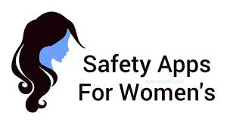

**2.2.1 HARDWARE REQUIEMENTS:**

▪ SERVER SLIDE

RAM : 512 MB

HDD : 20 GB or more ( free space excluding data size)

PROCESSOR : Intel® Core(TM) i3-5010U CPU @ 2.10GHz

▪ CLIENT SLIDE

RAM : 120 MB (minimum)

HDD : 10 GB or more (free space excluding data size)

PROCESSOR : Intel® Pentium® II Processor 400 MHz

**2.2.2SOFTWARE REQIREMENTS:**

▪ SERVER SLIDE

OPERATING SYSTEM : UBUNTU 14.0 LTS

WEB SERVER : FLASK

• CLIENT SLIDE

OPERATING SYSTEM : Windows 7

WEB BROWSER : Any browser compatible with Mozilla Firefox18.0.

or above.

**2.6 TECHNOLOGY USED:**

I. Geolocation API –used for getting the locations of users and volunteers.

II. Flask: it helps to create a web interface for our app and is to fetch the APIs and data.

III. Python: it is an interpreter, high-level, general-purpose programming language.

IV.Bluetooth-used for connecting web servers through each other.

**ARCHITECTURE OF MBRAKSHAK**

CALL FOR NEAREST VOLUNTEER BY USERS

VOLUNTEER

LOCATION

**SCREEN IMAGES**

**LOGO OF APP-:**



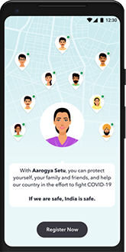

REGISTER NOW

REGISTER NOW AS

JOIN AS VOLUNTEER AND USER

JOIN AS VOLUNTEER

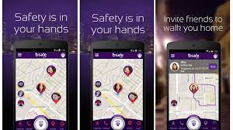

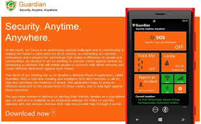

**MBRAKSHAK**

